MARYAM REHAN
WEEK 02
SAFE X SOLUTION
TOPIC: FREE SECURITY HYGIENE MINI-AUDIT
J. Junaid Jamshed — Clothing & Fashion Retail
Website: https://www.junaidjamshed.com

1. Business Overview
J. Junaid Jamshed (J.) is a clothing and fashion retail brand with an online shopping website. This mini-audit reviews basic, publicly observable security hygiene of the website and its domain. The assessment is limited to passive checks and does not include exploitation, intrusive scanning, or unauthorized testing.

2. Executive Summary
The website demonstrates a strong basic security posture. The Security Headers assessment returned an A grade, with X-Content-Type-Options, X-Frame-Options, Content-Security-Policy, and Strict-Transport-Security enabled. Referrer-Policy and Permissions-Policy were not detected. The domain also has an SPF record configured. Overall, the observed issues are low risk, but the missing headers should be addressed to further strengthen browser-side security.

3. Security Checks & Findings
Security Area | Finding | Risk | Recommendation
HTTPS / TLS | Website is accessible over HTTPS. | Low | Maintain valid TLS certificates and secure HTTPS configuration.
Security Headers | SecurityHeaders assessment returned Grade A. | Low | Maintain current secure-header configuration.
X-Content-Type-Options | Present. | Low | Keep enabled.
X-Frame-Options | Present. | Low | Keep enabled.
Content-Security-Policy | Present. | Low | Review periodically and keep policy restrictive.
Strict-Transport-Security | Present. | Low | Keep HSTS enabled with an appropriate policy.
Referrer-Policy | Not detected. | Low | Add an appropriate Referrer-Policy header.
Permissions-Policy | Not detected. | Low | Add a Permissions-Policy to restrict unnecessary browser features.
SPF | SPF record is configured; lookup entries show Pass. | Low | Review authorized senders periodically and keep the record updated.
DKIM | Not independently verified in the collected evidence. | Medium | Verify DKIM configuration with the organization's email administrator.
DMARC | Not independently verified in the collected evidence. | Medium | Verify DMARC and consider an appropriate enforcement policy.
Account Security | Public MFA/admin configuration could not be verified. | Medium | Use strong unique passwords and MFA for administrative and email accounts.

4. Evidence
Screenshot 1 — Security Headers result (Grade A)
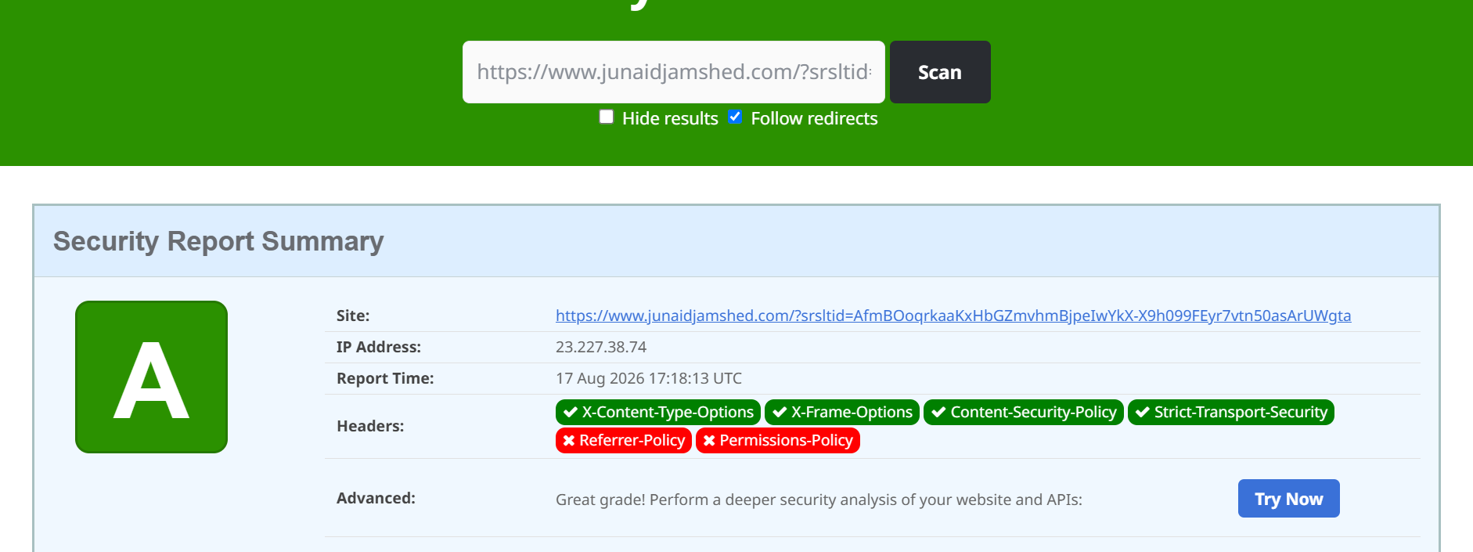
Evidence observed: Grade A; X-Content-Type-Options, X-Frame-Options, Content-Security-Policy, and Strict-Transport-Security were shown as present. Referrer-Policy and Permissions-Policy were shown as missing.
Screenshot 2 — SPF Record Lookup
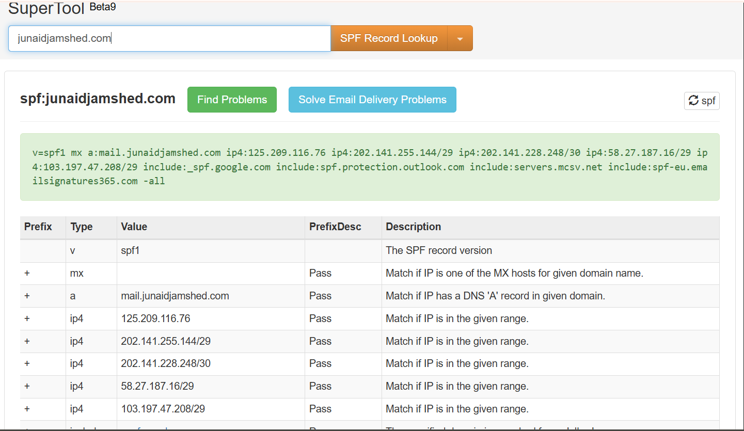
Evidence observed: an SPF1 record is published for junaidjamshed.com, with MX, A and IP-based mechanisms and multiple include mechanisms. The displayed lookup results show Pass for the visible entries.

5. Recommended Actions
- Add Referrer-Policy with a suitable restrictive value.
- Add Permissions-Policy and disable browser capabilities that are not required.
- Keep the existing Content-Security-Policy and review it after website changes.
- Regularly review SPF authorized senders and remove obsolete entries.
- Verify DKIM signing and publish/maintain appropriate DKIM records.
- Verify DMARC and progressively strengthen enforcement where operationally appropriate.
- Enforce multi-factor authentication for administrator, email, and other privileged accounts.
- Continue regular security-header, TLS, and domain-email security reviews.

6. Conclusion
Based on the passive checks and evidence collected, J. Junaid Jamshed's website shows good baseline security hygiene. The A security-header grade and configured SPF record are positive findings. The main improvement areas identified during this mini-audit are the missing Referrer-Policy and Permissions-Policy headers and the need to independently verify DKIM, DMARC, and MFA controls. Addressing these items would further improve the organization's security posture.

